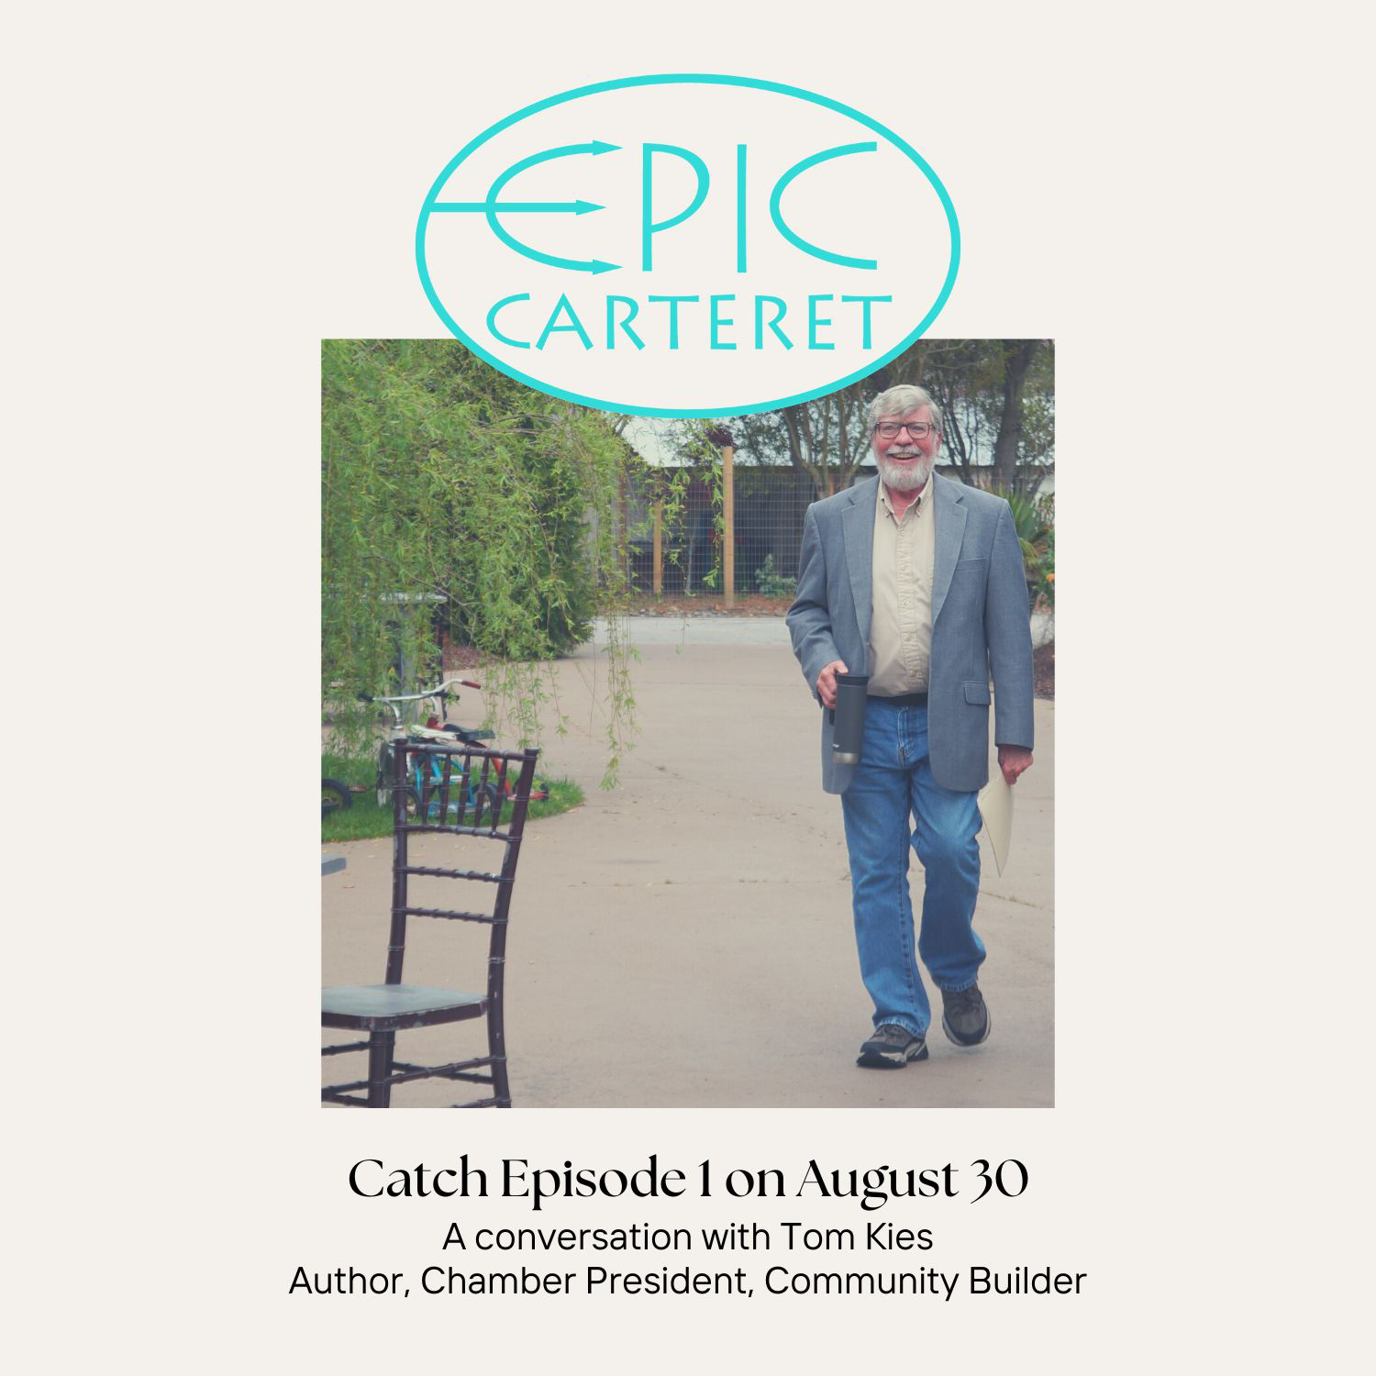

Epic-Carteret Episode 1

The Secret to A Thriving Business Community with Tom Kies

Transcribed by [Autumn Ware](https://autumnthewriter.com) with the help of [Hindenburg Pro](https://hindenburg.com)

[Intro Music with occasional Seagulls squawking]

## Intro

**Autumn (narration):** Welcome to Epic-Carteret. I'm your host, Autumn Ware. And I washed ashore on the Crystal Coast with my family in December 2020. I arrived, worn and weary, but within a year, I found myself converted from an exhausted traveler to an energized participant in this vibrant community. I'm a reformed recluse in a place that knows the secret of transforming strangers into neighbors. Now I'm on a quest to uncover what makes Carteret County such an extraordinary place to call home.

[music swells and fades]

**Autumn (narration):** The first stop on our journey is the community's dynamic business ecosystem, and our guide is none other than Tom Kies, Edgar nominated author of the popular Geneva Chase mystery series Like Me. Tom is a Carteret County transplant. He worked for newspapers and magazines in New York and New England for 30 years before moving south to become the publisher of N.C. Coast Communications in 2006. Not content to rest on his literary laurels, Tom served as the executive director of the Downtown Morehead City Revitalization Association for five years, and he's been the Carteret County Chamber of Commerce president for the last seven years.

## Tom on his arrival in Carteret County

**Tom**: I got here because I was offered a job as publisher, general manager of a magazine, local magazine company, and commercial printing firm.

I'd always wanted to be a publisher, and they offered me a position here. And I've never - I'd never been south of the Mason-Dixon Line before.

**Autumn**: Oh, wow.

**Tom**: I didn't even know that Morehead City, North Carolina. And actually, I was I was only planning on being in here maybe four or five years.

**Autumn**: **Oh**, wow.

**Tom**: And I was going to I was going to move back to Connecticut 17 years later, and here I am. It's home.

**Autumn (narration):** What's kept Tom here all this time? The pristine beaches, the wild horses, those delicious crystal Coast oysters. No doubt they add to the allure, but it's the community that Tom finds extraordinary.

## Why Tom is Still Here

**Tom**: The sense of community is really, really strong here. We've made some wonderful friends and I've gotten some know some just super people. You're one of them. I mean, you know, it's just yeah.

**Autumn:** Thank you, thank you.

**Tom**: It's fun to meet new people, and people want to help. It's you take a look at what happens after, like Hurricane Florence and it's an amazing place.

[Music swells and fades]

**Autumn (narration):** So it's the community that keeps Tom here, the community and maybe Floyd's 1921 restaurant in Morehead City, where we recorded our epic interview

## Tom on Floyd’s 1921 restaurant

**Tom**: they've got to it's got a few chefs who work here. One of them is French, so they actually excel in French cuisine. So you can get gourmet cooking as well as homemade meatloaf. It's just great. The service is wonderful. I know everybody here and I know the owners and the owners once again, are just really, really big in the community. So love them. Just we just there's no other place I like better than this. I bet there are some wonderful restaurants. And then my wife and I go out and eat there all the time. But this is my favorite.

**Autumn (narration):** Today, we're noshing on Chef Floyd’s redneck eggrolls. Crisp, savory bundles of barbecue that were featured on Food Network's Diners, Drive-Ins and Dives in episode 36 “Rolled and Holed.”

**Autumn**: what's your favorite appetizer?

**Tom**: The redneck eggrolls.

**Autumn**: I love those too! That's the first thing I ever heard from your area.

Why do you like those? Why was that your favorite?

**Tom**:They're the really unique. I mean, they've got a super taste. I've watched them put them together and it's just it's this combination of flavors that you would not expect would work together. Yeah. And they've got the so much that goes with it that's just a little bit out of this world. So yeah, it's always my favorite.

**Autumn**: And this is where you do your Geneva Chase Mystery launches.

**Tom**: I do all of my Geneva Chase launches [here]. The only one that I didn't do was when I did the dinner theater at the culinary school.

**Autumn**: So still really still there's still a Floyd's connection.

**Tom**: And as a matter of fact, one of the co-owners of Floyd's runs the Culinary School. And she asked if I would do that theater in order to cook kick off my book last year, which we did.

## Tom’s defining characteristics

**Autumn (narration)**: In 2022, Shana Olmstead, co-owner of Floyd's 1921 chamber board member and chair of the Culinary Program at Carteret Community College, asked Tom to branch out from writing novels and pen a dinner theater play to help raise funds for Carteret Community Theater, his new facility. The old one had been destroyed during Hurricane Florence. Eager to help, Tom wrote Death of an Author, which the theater performed to two sold out audiences in his new culinary building. Tom wrote himself into the play as the titular main character and killed himself off right after the salad.

**Tom**: right after the salad.

**Autumn**: Right after the salad. So this question should be easy for you. Let's imagine that you are the protagonist of a story. What are your defining characteristics and what's your story arc?

**Tom**: Well, first of all, when I when I write a book, I'm always the protagonist of the story. There's some of me that goes into each character and that includes the bad guys. You are you are part of all those characters. There is you write down. So the overarching theme for my protagonists is they want to do the right thing.

Sometimes they don't always know what that is, but in the end, they want to make things right and they will go to great lengths to make that happen. And I, and I would like to think that I'm the same way. I'm not as brave as my protagonists, and I certainly don't have the chutzpah that my protagonists have, but they are all me.

## Tom’s core values

**Autumn (narration)**: Having met Tom and read his novels, I can see the similarities between the author and his tenacious protagonist, Geneva. And Tom's desire to do the right thing is apparent in all the things that he does. It's a quality that I find in many of the local folks I find so impressive. They see a challenge and they start looking for solutions, but they don't go at it single handedly. They work cooperatively in the same way that Geneva Chase partners with other professionals to solve crimes. In addition to his roles as the president of the Chamber of Commerce, author and now playwright Tom serves on the board that advises Noah on the management and protection of the Monitor National Marine Sanctuary. And since 2016, he's served as the president of the Business Alliance for Protecting the Atlantic Coast, advocating for the responsible stewardship of coastal waters.

**Tom**: We represent 43 businesses from Maine to Florida. Yep.

**Autumn (narration)**: Tom also shares his time and talents with people in his community who look to him for creative inspiration. He teaches creative writing through the community college life enrichment program. When I first got to town, I was like a lot of people in 2021 in a real creative slump and definitely in need of enrichment.

In his class, Tom encouraged us to write, of course. He was supportive and inspiring, as you'd expect, having met him yourself now.

But I think the most powerful thing he did, for me at least, was to cultivate a sense of community in his classroom.

He also encouraged us to get involved with the local writing community, Carter at writers, which had suffered setbacks during the pandemic.

Tom's community spirit is contagious, and within months of meeting him, I found myself not only a member of the writing group, but on the board alongside three other graduates of this creative writing class.

In the spring of this year, we celebrated the Carteret Writer's 40th anniversary with a conference that brought together writers from all over eastern North Carolina. And as far away as Baltimore. It was a fantastic and really fun feat that wouldn't have been possible without Tom's commitment to the writing community.

**Tom**: That was fun!

**Autumn**: Yes, it was so much fun!

[Music swells and fades]

**Autumn (narration)**: Tom is a community builder, but he's not the only one. It's a quality I see frequently on the Crystal Coast. A desire to work with others to serve the greater good. So I wanted to know:

**Autumn**: What are the core values that drive this commitment to community involvement that you have?

**Tom**: I always want to leave the community a little better place than when I walked into it. Any anytime I'm with an organization, I want it to be better off than when I first started. So with the Chamber of Commerce, I want it to be a better organization than when I first started. It was great. When I started, I wanted to be a little better when I was working for downtown. We make some great strides downtown. I'm so proud of the work that we did down there When I was working for the magazine company here in the community, we did some really cool stuff, not just for the company but for the community.

[Music rises and fades]

## How Carteret County has changed since Tom’s arrival

**Autumn (narration)**: Like many places, Carteret County has been the scene of massive changes during the last few decades. There have been upheavals like Hurricane Florence and advances like the blossoming culinary arts program at C.

Ultimately, each has been an opportunity to leave the community a little better than it was. And Tom's had a front row seat for many of the changes that the area has undergone. Not that he ever has time to sit down.

**Tom**: Sure. I'll tell you, it's a lot different than when I first moved here 17 years ago. downtown Morehead City. You could literally fire off that cannon and not hit another soul. And now you're lucky if you can find a place to park. So it's changed a lot. People have discovered that this is a great place to live. Not just a great place to come on vacation, but a nice place to raise kids. You can work here. You can work remotely.

**Autumn**: Yeah, it really has a little bit of everything. I mean, and also just the different pocket communities, you know, like each little area is so different, Beaufort is so different.

**Tom**: Each area has its own identity and don't get them confused

**Autumn**: That's what makes this area so cool. Each area has its own identity and I love that.

**Tom**: Once again, we kind of go back to the quality of life, the arts, improve the quality of life in the arts will include things like food. We have some of the best cuisine in all of North Carolina, if not the East Coast.

We have wonderful music. All you have to do is go out in the evening to almost any restaurant or bar. The music here is unparalleled. Um, you know, we have some terrific art galleries and art organizations that support the arts. And of course, of course, I'm partial to the Carteret Writers group, which there's a resurgence in that. I am really excited at how many writers we've got here. We've got good writers in Carteret County.

**Autumn**: Yes, we do.

**Tom**: That all helps improve the quality of life. It's amazing - it's an amazing location. That's one of the reasons why even after retirement we’re planning on staying here. This place is our home.

**Autumn**: This is the place to retire. I feel like I'm retired even though I'm not.

[music rises and fades]

## Back to Work

**Autumn (narration)**: It's easy to get off track, waxing poetic about Carteret County's laid-back lifestyle and cultural scene, especially with a fellow writer. But that's not what we're here for in this episode of Epic-Carteret.

I want to understand how the county's business ecosystem encouraged jobs, mutual fruitfulness, and a desire to work together for shared benefits.

Tom's foray into playwriting offers a perfect example of what I'm talking about. In this massive collaborative effort to raise funds for the new theater. Tom brought his creativity and his headline or popularity to sell tickets, which also happened to put more eyes on his latest Geneva Chase thriller ‘The Whisper Room’.

The community theater folks deliver their own creative gifts, including a dead ringer to play the fictional Tom Kyes, and reminded the community of the value of supporting the local cultural arts.

The community college culinary department provided the setting and the delicious dinner, and it was also an opportunity for students to show off and hone their skills in a fast paced, real-world situation.

And locals got to support a good cause while enjoying a fun night out on the town.

It's when's all the way down. And from what I've witnessed since moving to the Crystal Coast, that's more common than not. But how?

[Carteret County’s thriving business scene]

**Tom**: Well, that's, that's the hard part, now. That's the magic trick.

Especially in an area like this. There are three points to economic development in this community. One is good health care and we've got excellent health care in Carteret County. One is good schools and we've got some of the best public schools in the entire state of North Carolina, I am proud to say. And the other is quality of life. Quality of life here is really, really important.

So, if you're starting a business, you've got to keep that in mind. You don't want to start a business that's going to make that up. Yeah, you know, you - you want to start a business that's compatible to all of that. And most of the businesses we have here are small businesses that are locally owned and they're aware of that.

And they are, they are pretty much all community oriented. They want to succeed, but they also want to see the community succeed. So, it's a symbiotic relationship.

**Autumn**: Yeah, I mean, like said, when we were talking to Chef Floyd earlier, the way that restaurants work together

**Chef Floyd**: Oh, my gosh. Yeah. I mean, there's a lot of wonderful restaurants here in Carteret County. Yesterday, my wife and I had took a day off finally, and we went travel to another restaurant to eat and support them. And it's all we help each other out,

**Tom**: The businesses do that, and the nonprofits do it. There are some communities I've been in where nonprofits are competing with each other because there's only so many nonprofit dollars available. But here they're all very, very - they help each other. If you need a hand with something, they're always there. I've never had anybody say no.

[Music rises and fades]

## Advice to small business owners: get involved.

**Autumn (narration)**: So, let's say you, like me, are a small business owner or entrepreneur in Carteret County, and you want to reap all the rewards of this thriving business community. You want to do the right thing. You want to solve problems. You want to work with other go getters like Tom. Where do you start?

**Tom**: if you really want your business succeed, you know, go to the business after hours, go to the ribbon cuttings, go to the all the go to as many events as you can.

Because one of the things I learned when I first got here, people want to do business with people they know. They don't want to do business with people they don't know. It was advice I got when I first got here and its advice that I give.

**Autumn (narration)**: If you recall, I mentioned that I'm a reformed recluse. I've been a chamber member in one place for another since I started my copyrighting business in 2013 in New Orleans. But my chamber membership was about as active and useful as any gym membership I've ever held. I got the card that says I'm a member. Are you telling me I got a common side and workout too? Come on, now that seems like a little bit much.

Likewise, chamber networking events have traditionally been polite, but firm. No, thank you for me. The Carteret County Chamber hits a little different, though, with beach music and a bar and all that delicious local cuisine Tom's been on about. Allow him to likewise paint a picture of the community's more relaxed approach to building a professional network.

**Tom**: When I first got here, I went to this huge event. It was a Chamber of Commerce event over at Sound Bank, and they had it on their parking lot and they had a live band, and it was catered by Hooters. And, you know, there must have been 400 people in that parking lot. And I had just moved here from outside of New York City. So, for me going to these things was speed dating. How many cards can I hand out? How many cards can I get, How many people can I meet, how many hands can I shake? And I started doing my shtick and somebody came up behind me and they put their hand on my shoulder and they said, “Son, I'm going to give you a piece of advice. Slow down. People want to get to know. They want to talk about hunting. They want to talk about fishing. They want to talk about Bubba who got arrested last night. Relax.”

Best advice I ever I ever had. Get involved and just get to know people, talk to them. And you don't even have to try to push your business right away. Get to know what they feel they're interested in, and it'll come, and you'll be successful.

## How to get involved

**Autumn (narration)**: Easy for someone as suave and self-assured as Tom to say. But what if you're somebody like me new to this whole community thing? How do you get involved if you want to help make things better? But you don't even know where to start. Tom has straightforward advice for that.

**Tom**: be a joiner, be part of the Chamber of Commerce, be part of the Arts Association, be if you're writing, be part of the pirate writers, I highly recommend that be where other people are and you can see what's needed and how you can be part of that group and what you can do to help. That's, that's that really is it. You just have to reach out and do it.

[music swells and fades]

## Leadership Carteret

**Autumn (narration)**: If you want to live in an epic community, get involved. Tom's message couldn't be clearer. But it's not always easy to know how to go about it, especially if you're a reformed recluse, like me.

There are so many communities in this community. How do I know which ones to join? What will I have to do when I'm a member? Will there be pancake breakfasts?

Carteret County's Chamber of Commerce saw all your questions, and they've developed a way to help community minded people like you get to know your community better. It's called Leadership Carteret.

**Tom**: We have about 30 people that go through the class every year and we show them the good, the bad and the ugly. We teach them about government. We teach them about the education programs that we have here. We take them backstage at the aquarium. We take them out to Cherry Point.

**Autumn (narration)**: The participants play games, take field trips around the county, and practice working together to overcome obstacles, including climbing the infamous 20-foot wall at Camp Albemarle. No leader is left behind. The Leadership Carteret program is transformative for the participants.

**Tom**: We've had people who grew up here and by the end of ten weeks, it's a, it's a really concentrated program. At the end of ten weeks, they will have seen and learned things that they didn't know existed in Carteret County, When you're done, you might have a few bruises and a few scratches, but everybody is tight and bonded, and they stay tight and they stay bonded. I've got friends I took the class with back in 2007. We'll be friends for the rest of our lives.

**Autumn (narration)**: And I think it's fair to say Leadership Carteret is transformative for the community.

**Tom**: We give all of them a community project to work with. We work with nonprofits like Hope Mission and Habitat for Humanity, and they'll continue to work for those organizing missions even after the leadership program is over. And you see a lot of the people that sit on the boards and raise money. There are folks that went through the leadership program. There's no way to measure it. But if you if you go to almost any place and it's a group of volunteers or a community group of any kind, ask how many people here in this room went through leadership of right, you'll be amazed at how many people raise their hand.

## Conclusion

**Autumn (narration)**: We started this episode asking “What's the secret to a thriving business community”? And Tom offered a pretty compelling answer: genuine engagement. Instead of aggressive marketing, focus on building genuine personal connections with the people around you, participate in events and get to know others in your business community to foster trust and cultivate mutually fruitful business opportunities.

Tom Advises joining the community groups that move you like the Chamber of Commerce, the Arts Association, and Carteret Writers as a way to engage with others and identify community needs. And of course, participating in programs like Leadership Carteret can provide you with an even deeper understanding of the county, its operations, and its challenges.

[Music Swells and fades]

I met Tom when I came out of my little hermit crab shell. Long enough to take his creative writing course at the college. Because I'm a former teacher and a lifelong teacher's pet wannabe, I knew that sitting in a classroom would force me out of my creative slump. That one little step put me in relationship with some of the most creative, encouraging, and downright epic people of the Crystal Coast, including my next guest, Amanda McCall, a Carteret County educator who, like Tom, has a knack for pulling people together to make the place better.

So, make sure to join us September 27 as Amanda shares how she uses cooperative efforts to better serve Carrboro County's community of learners.

Also, visit Epic-Carter.com to read essays and articles by local writers that offer more insights into all the things that make Cartwright County epic. To learn more about Floyds 1921, including their ties to his incredible Escoffier program and to find links to all the organizations and programs mentioned in this episode.

If you'd like to support Carteret Community Theatre's new theater, visit [CarteretCommunityTheatre.com](https://carteretcommunitytheatre.com). That's. T. H. E. A. T. R. E dot com. There's a link on the Show notes page.

[Outro music swells]

Before we wrap up, I'd like to take a moment to extend my heartfelt thanks to those who made this episode possible:

* Tom, for generously sharing his insights, experiences and advice on the significance of community involvement for small business owners.
* Chefs Floyd and Pasco, Shana Olmstead, Jason Eure and everyone at Floyd's 1921 who welcomed us for the interview.
* Cartwright County's Chamber of Commerce for their wonderful initiatives, especially the leadership prep program and for their dedication to fostering community growth and involvement.
* I'd like to thank Melissa Kelly, Emily Carter and Jen Hieronymus, my fellow Cartwright writers board members who pulled me the rest of the way out of my little hermit shell. I would not have done this without you.
* And to Jack, where my beloved husband and sound engineer without whom this episode wouldn't have come to life.
* Last but by no means least a big thank you to you epic listeners. Your support and eagerness to learn and grow with me and make all of this possible.

Stay tuned for more epic Carteret. And remember, if you're curious to know what it takes to create an epic community, the answer? Maybe you.