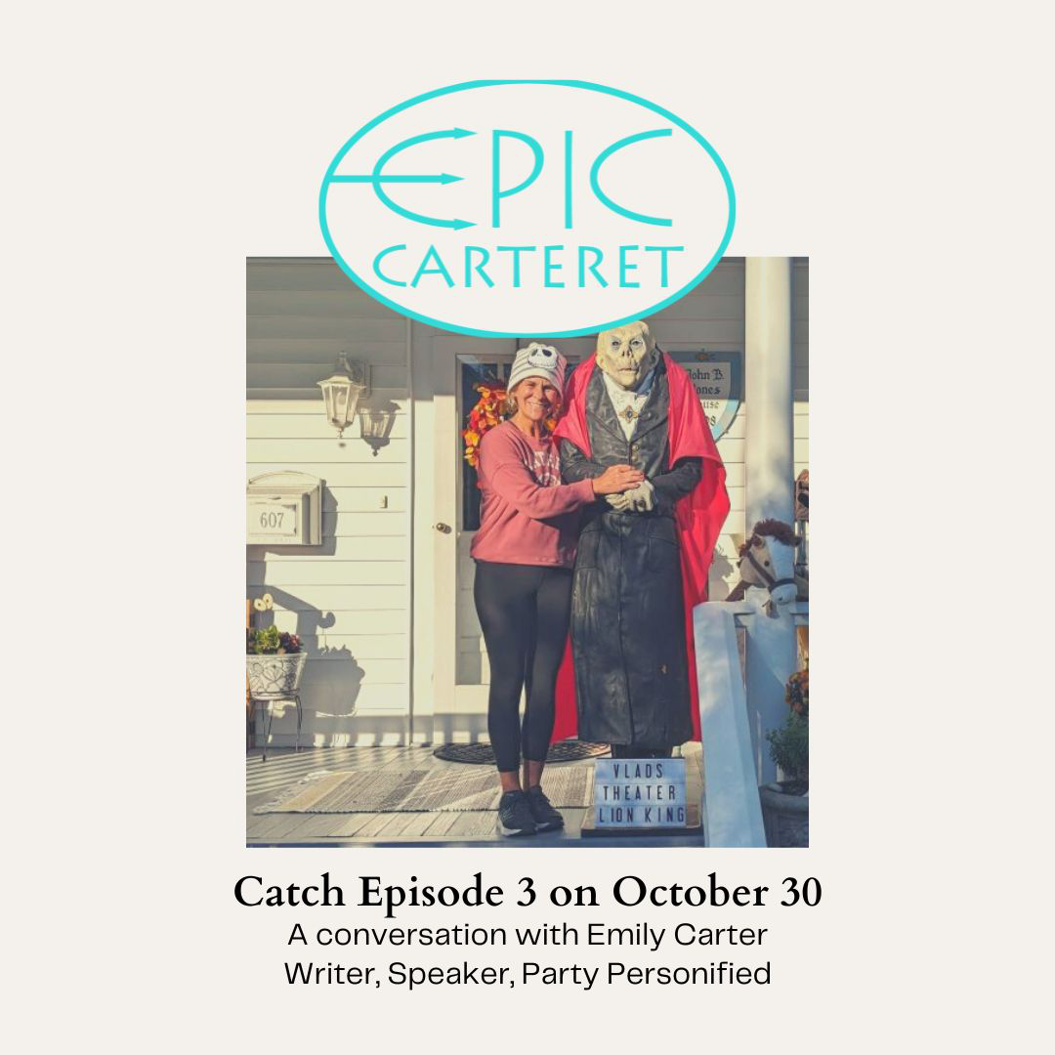

Epic-Carteret Episode 3

Making space for celebration in communities with Emily Carter

TRANSCRIBED by Autumn Ware with the help of Hindenburg Pro

[Intro Music with crows cawing]

Intro

Autumn (narration): Welcome to EPIC Carteret. I’m your host Autumn Ware, and I washed ashore on the Crystal Coast with my family in December 2020. I arrived worn and weary, but within a year, I found myself converted from an exhausted traveler to an energized participant in this vibrant community. I’m a reformed recluse in a place that knows the secret of transforming strangers into neighbors. Now, I’m on a quest to uncover what makes Carteret County such an extraordinary place to call home.

[music swells and fades]

Autumn (narration): In Episodes 1 and 2, we talked about cultivating a thriving business scene and about cooperative growth among learners. In this episode, we’re going to consider the role that shared celebrations play in community-building.

Community celebrations allow us to commemorate our shared history and achievements, to foster an appreciation of our diverse cultures, and to bring people together in a spirit of joy and gratitude. Local celebrations offer an opportunity for dialogue and cooperation, which cultivates greater understanding.

Regular social events, seasonal celebrations, and annual festivals serve as vessels for our shared memories. They allow us to raise the loving cup high and offer a heartfelt libation to this beautiful world we share.

My guest Emily Carter, a Beaufort-based essayist and songwriter, had this to say regarding the value of making space for joy in our communities.

[music swells and fades]

Autumn (narration): I met Tom taking his creative writing course at the college. And because paths intertwine in such close knit communities, I was introduced to our next epic guest, Amanda McCall, another lifelong learner, and Decatur County educator. Through a fellow classmate in that same course in episode two, Amanda and I are setting our sights on the educational horizon to consider how a community of learners can make progress together. Could it be that a collective commitment to personal growth is one of the secret ingredients when you're cultivating an epic community?

Autumn (narration): But before we dive in, I have a confession to make. I have no idea what I'm doing. I've never produced a podcast before, and I'm learning as I go. As an educator myself, I know that a big part of learning is screwing up. And I have experienced a few epic fails already. Fortunately, Amanda is the pinnacle of patience and encouragement. If you're going to really screw up in the service of trying something new. She is the exact person you want sitting across the table from you.

Joy is soul food

Emily: I think it's soul food. It’s not all fun and games, but it could be much more.

Amanda: It could be so much more.

Autumn (narration): In difficult times, the experience of joy is nothing short of a miracle. But joy helps us cope with life's challenges. It improves our health. It strengthens our relationships.

Having fun and celebrating with your people isn’t frivolous; it’s a way to heal the human spirit. They remind us that life is more than the mundane routines that often consume our days.

Local celebrations, like Morehead City’s Seafood Festival, Beaufort’s Pirate Invasion, or the Beach Music Festival in Atlantic Beach, allow us to stop and savor the special people, places, music, and moments that give our lives meaning.

[music swells and fades]

Autumn (narration): I can’t imagine anyone more suited to this topic than Emily. In her role as the Vice President of Carteret Writers, she was pivotal in planning in the group’s recent forty-year anniversary. Emily is also on the board of the Penguin Plunge, the Crystal Coast’s annual New Year’s celebration, and she absolutely embodies the spirit of celebrating life's moments, big and small.

If you were to look up “fun” in a dictionary, you’d see her photo there – if you could get her to be still long enough to take a photo.

In Episode 3, Emily and I consider how shared celebrations foster a more generous sense of community spirit, and the best place to start is right at home, which is where we recorded our interview. Specifically, we were in one of Carteret County’s favorite Halloween haunts – Ann Street in Beaufort. Allow Emily to set the scene.

[music swells and fades]

Halloween on Ann Street in Beaufort

Emily: The cool thing, which I’ve never experienced anywhere else before, is everybody dresses up… John and I are going to be Gomez and Morticia this year. The families. It's not just the children dressed. The whole family has themes. They're walking around, and their children are trick or treating, but the whole family is dressed up. The vibe is magical.

The first year that we were here, a young girl, she was maybe ten or 11, was dressed like an equestrian, and she had a live miniature pony as part of her custom. So it's just fun and laughing.

Everybody participates. I think it's just a vibe. And you want to be part of it.

Autumn (narration): Before she moved to Carteret County, Emily and her husband John, a musician lovingly referred to as Emily’s Smokin’ Hot Love Biscuit, prepared s’mores in their firepit for neighborhood kids on Halloween night. Her new Beaufort neighbors quickly put an end to that old tradition, telling the fun-loving couple:

Emily’s First Year on Ann Street and the COVID Halloween

Emily: You do not have time for that. And we are like, I was taken aback. Like, what does that mean? We have time for a lot of things. And then the first year that we were here, we had over a thousand trick or treaters. She was right. And we were giving out candy as fast as possible.

That was 2019. And then the following year, COVID hit.

So the second year we turned our house into a pirate ship. We thought the world needs something really good, and John devised these PVC pipes, which were the candy cannons. We mainly did it for social distancing because of COVID. But we also did it because these kids have had a really hard year. And if they are brave enough to come out and trick or treat and try to have as normal experience as they can on the Halloween of 2020, then we're going to give them something worth it. So much fun. The kids immediately like put their bags under the cannon and we’d fire these bags down. And that's when we became known as the Halloween house.

Autumn (narration): COVID put a lot celebrations on hold, but Emily and John recognized that, especially during challenging times, people of all ages need a reason to laugh, to play, to greet neighbors, to welcome strangers – even if doing so requires a little ingenuity, like turning your house into a pirate ship and PVC pipes into candy cannons.

Creating a space for joy isn’t always easy. In fact, it can be a lot of hard work. Can you even imagine preparing for more than one thousand trick or treaters? Emily is smart enough to know it takes teamwork and elbow grease to orchestrate a community celebration, and she makes the work more enticing by turning it into a party all its own.

Candy Assembly Party

Emily: We’ll have a party Wednesday night. Not really a party, but we'll have a candy assembly party on Wednesday. Twelve of our friends will come over. We’ll each do 100 bags, four pieces of candy in each bag, for the candy cannons. You know, and people will bring candy and donate it. But, yeah, we have a budget line item in our family budget for Halloween.

Autumn (Narration): Emily and John’s COVID Halloween shows how the spirit of play can thrive, even in challenging times, when people choose to share their gifts generously to uplift others. What’s more, they’ve found that airing their skeletons in public can also be cause for celebration.

That’s right. From the first of October until the 31st, Emily and John create a haunting new Halloween display in their front yard each day. The scenes star a hand-me-down vampire called Vlad and his skeleton crew up to silly seasonal antics.

The origins of Vlad’s Lookout Lodge

Emily: So a friend of ours gave us Vlad. We adopted Vlad in 2019, and he became the anchor. In 2019, we only changed the scenes about ten days. Then in 2020 we started doing a scene every day. Since then, we've never duplicated a scene and we do it every day in October.

Today, we did a scene from The Lion King, and we just were laughing so hard. John and I do it together. At the beginning of October, it seems it seems daunting, but now here we are, the 23rd, we have more scenes now that we can do.

Autumn (narration): Over several years, this spirited family tradition has become a tradition for dozens if not hundreds of other Carteret County families who come out to enjoy the daily performance of the Carter House ghouls.

Family traditions and Vlad’s mom

Emily: Families come by every day. People take pictures, they send them all over. We put it on social media, but there's a little boy, Max, and maybe was four that first year. He got on the porch every day and had a picture made beside Vlad every single day. The next winter, I saw him in a coffee shop and his mom said, “Who's that?” And she was trying to explain who I was. And he didn't get it. And finally she said, “It's Vlad’s mom.” And he went, “Oh! Vlad’s mom!”

It's a good thing. John and I want to be known for people who are generous, who put smiles on other people's faces, who are contributors, that we are giving good to the community and into the world.

[Music swells and fades]

Autumn (narration): In addition to being a Halloween queen, Emily has also been the Vice President of the Carteret Writers since 2021. A local non-profit committed to supporting and encouraging writers on the Crystal Coast, Carteret Writers was founded in 1983 and quickly became a pivotal part of the local creative community. But COVID took a toll on its membership and its vitality.

Like many organizations in the wake of the pandemic, Carteret Writers was facing the very real possibility of collapsing just before it could make its forty-year anniversary. But unlike many organizations, Carteret Writers had Emily, and Emily immediately set about saving the organization by recruiting new board members, including yours truly.

Prior to arriving in Carteret County, I’d never served on a board. I had only the vaguest idea of what a board even did, and none of it sounded like fun to me. But Emily changed my mind. I knew if she was going to be a part of it, it would be a good time, and that made it a lot easier for me to say yes to helping.

How Emily got involved in Carteret Writers

Autumn: What motivated you to join Carteret Writers board? Because you were the impetus for everybody. You bullied the rest of us into joining the board.

Emily: I did. I’m proud of that.

Autumn: So what was it that motivated you?

Emily: I think I went to meetings before COVID shut the world down, and the existing president was fabulous and is still serving on our board now. But he stayed well beyond his term trying to hold it together. And then he kept trying to entice people to take over or he was going to dissolve the organization. And then I got, you know, in my mind, gosh, this is a 38-year old group that's going to be dissolved if we don't save it. And that's when you and Jen [Heironimus, the current treasurer] and Allison [Daniel, the former treasurer], Melissa [Kelley], Stanley [Trice, the former president], the other people that have been part of that, Trish [Sheppard, local poet and artist] and Jan [Parker, local writer and artist], as well, that helped save it. But yeah, it was a Hail Mary.

Autumn (narration): Two years later, Carteret Writers is thriving again with monthly socials that give writers a chance to practice their craft, get feedback on their work, and spend time with people who share their passion. We celebrated this renaissance and the group’s fortieth-anniversary with the organization’s first writer’s conference in April of this year. Local author Tom Kies was the event’s master of ceremonies, and writerly revelers came from near and far to share in our successes. After such a close brush with dissolution, it’s hard to imagine a more rewarding revival.

We put on a class-act conference

Emily: We put on a class-act conference. I mean, we got the attention of North Carolina Writers Network. I mean, Ed Southern came. I thought it was great. And I saw people really, really just be in their element. I think the speakers were in their element, and the writers were learning, and Carolina Home and Garden is a fantastic venue. Yeah. I was so proud of that day.

Autumn (narration): Every member of Carteret Writers felt proud that day because we’d worked together to make it happen. Past President Stanley Trice worked in lockstep with the group’s current President Melissa Kelley, and a tireless committee of volunteers found small pockets of free time between work hours, family responsibilities, and regular, everyday crises to make our vision for a conference a reality.

People support a world they help create

Emily: When I used to work for Dale Carnegie, one of the things that they always said was “people support a world they helped create.” And I feel as though we've seen that with Carteret writers, that people knew that this was a chance for them to offer a voice and contribute, with their writing, but also in what the conference was going to look like. Yeah, I think we've seen that, especially with some of the more active members, we see that with Jessie [Waugh] and really solid writers who have stepped up their game, started consistently blogging and submitting more to contests. And that's just great to see.

Autumn (narration): Carteret Writers is invested in celebrating its members from glow-ups in the monthly newsletter to interviews on the gtoup’s blog. And it pays off when writers gain the confidence to take creative risks, something that comes from feeling valued and appreciated by your community for your unique contributions.

[Music swells and fades]

Autumn (narration): From celebrating the creative voices in our local literary community, we now shift our focus to a broader community celebration that takes the plunge into icy waters, all for a good cause. On January 1st, hundreds of bold Carteret County folks brave the Penguin Plunge to raise funds for local charities and celebrate the spirit of renewal in Atlantic Beach.

Emily and John first got involved with the Plunge in 2021, when they were asked to fill in the very big shoes of the previous master of ceremonies. They were so taken with the community spirit of the event, they joined the board the next year.

The Penguin Plunge

Emily: The Plunge is so inspiring to me. People sponsor it. People register. People buy t-shirts. People are uncomfortable. Some people go all the way in and some people take the Presbyterian approach and sprinkle water on themselves. People are washing off the old and so many good things about it. And it's almost 800 people that do it at Atlantic Beach.

Autumn (narration): While I’m not one who’s going to dive into the Atlantic Ocean to mark any occasion other than perhaps a leaky boat, Jack and I did dip our toes in at the Plunge last year, and it was a memorable way to ring in a new year, especially knowing our contributions were going to benefit the local community. If it sounds like something you’d like to dive into, you’re in luck!

The Penguin Plunge application process

Emily: The application process is actually open now through November the 15th. It has to be a 501c, and the board selects the charity. Okay. So for example, for the Plunge on January 1st of 2024, the charity is East Carteret Band Boosters, and they're going to use the money to take a band trip, and kids who maybe wouldn't be able to afford the trip, that money will be used to finance their part of the trip and uniforms and instrument upgrades and all the things that band kids need.

[Music swells and fades]

Autumn (narration): By now, I’m sure you can see what a perfect fit Emily is for this particular episode of EPIC Carteret. She’s a walking celebration, and her good times mean more good times for more people on the Crystal Coast.

Her Halloween ingenuity lifted the spirits of hundreds of socially-distanced kids during the pandemic, and her fun, festive displays have become part of her community’s annual traditions. The Carteret Writers conference, which wouldn’t have happened without Emily, raised funds for Amanda McCall’s Title Wave bookmobile, and the Penguin Plunge contributes to different local charities each year. So where in the world did Emily learn this knack for making good times happen, even when times are hard?

How Emily learned to create space for fun and play

Emily: I did not grow up with money I my family was low low on the low end of middle class if we were middle class.

I grew up in a fun household. I mean, I grew up on a farm. My parents both had jobs, but we also had, you know, you go to work and come home and work. And on Sunday, we played baseball in the yard. Or if for some reason it snowed, and the power went out, we stayed up all night playing cards. My parents knew how to create fun. They just did.

And both of them came from big families and neither were ever so animated and happy as when they were around their siblings and family, which always said to me that that must have happened in their homes too.

Autumn (narration): Joy and celebration are soul food, absolutely necessary for our nourishment – and not just for kids. Grownups need to have fun, too, as a reminder that there’s more to life than bills and bad news. Maybe you didn’t grow up in a fun family like Emily, but cultivating more fun and spreading a little more joy can be as easy as a hop, skip, and a jump. Here’s Emily’s suggestion for getting started.

Be intentional about bringing joy into people’s lives

Emily: be intentional about bringing joy into people's lives. If you want to have a game night, have a game night. Or do something that's fun. Sometimes when I walk my dog, randomly, this isn’t just here. It's been multiple places, and I'll see that there's a hopscotch drawn on a sidewalk. Go hop on it. Stop and swing. Do something that feeds that fun and play side, and just create some joy.

Autumn (narration): In this episode, we've explored the profound impact of shared celebrations on community spirit through the lens of Emily's colorful contributions. Her enthusiasm and sense of fun made it easy for a reformed recluse like me to say yes to doing more. Even if I’m not sure what I’m getting into, I know it’s going to be a good time with Emily.

From creating captivating Halloween displays to her involvement in the Carteret Writers and the Penguin Plunge, Emily's dedication to fostering joy and togetherness exemplifies some of the core values that make Carteret County a truly special place.

Shared celebrations create an enduring sense of community, and opportunities for celebrations abound on the Crystal Coast. Whether you want to dance the night away with new friends, celebrate a special occasion with a loved one, or just take a moment to show gratitude for this beautiful place we call home, you’ll find more than your share of joy in EPIC Carteret.

[Music swells and fades]

Autumn (narration): Our next episode of EPIC Carteret will be our last of 2023, and we’re going to consider how a culture of caring enriches a community. From the Title Wave Bookmobile to The Bridge Down East, dedicated volunteers and staff at charitable organizations in Carteret County provide much-needed services to vulnerable residents.

How can epic communities empower more people and cultivate a culture of caring? Join me in November to explore how caring for more people can enhance everybody’s quality of life.

Visit epic-carteret.com to find photos of Vlad’s Lookout Lodge and links to all the organizations and programs mentioned on the Episode 3 show notes page.

If you’d like to join the Penguin Plunge, visit the website to pre-register and/or donate. There’s a link on the show notes page for that, too.

You can also read essays and articles by Emily and other local writers on The EPIC Blog, and if you are a local writer, you’re cordially invited to enter the EPIC Carteret Winter Hauntings Ghost Story Contest. General submissions will be open October 31 through November 13, the winner will receive a $100 cash prize, and we’ll be toasting the top contenders at a ghost story celebration in January 2024.

[Music swells and fades]

Autumn (narration): Our next episode of EPIC Carteret will be our last of 2023, and we’re going to consider how a culture of caring enriches a community. From the Title Wave Bookmobile to The Bridge Down East, dedicated volunteers and staff at charitable organizations in Carteret County provide much-needed services to vulnerable residents.

How can epic communities empower more people and cultivate a culture of caring? Join me in November to explore how caring for more people can enhance everybody’s quality of life.

Visit epic-carteret.com to find photos of Vlad’s Lookout Lodge and links to all the organizations and programs mentioned on the Episode 3 show notes page.

If you’d like to join the Penguin Plunge, visit the website - Penguin Plunge Atlantic Beach - to pre-register and/or donate. There’s a link on the show notes page for that, too.

You can also read essays and articles by Emily and other local writers on The EPIC Blog, and if you are a local writer, you’re cordially invited to enter the EPIC Carteret Winter Hauntings Ghost Story Contest. General submissions will be open October 31 through November 13, the winner will receive a $100 cash prize, and we’ll be toasting the top contenders at a ghost story celebration in January 2024.

[Outro music swells]

Before we wrap up, I’d like to take a moment to extend my heartfelt thanks to those who made this episode possible:

1. Thank you, Emily, for all of your work cultivating community, for making life more fun, for bringing joy with you wherever you go and for making time in your very busy schedule to help a friend.

2. And thank you, Mr. Biscuit, for commanding the candy cannons and entertaining Toast in the Man Cave during this interview.

3. Thank you, Jack, my EPIC sound engineer, for ten years of shared celebrations.

6. Last but by no means least, a big thank you to you, EPIC listeners, for celebrating this incredible county with us.

Stay tuned for more EPIC Carteret, and remember, if you’re curious to know what it takes to create an epic community, the answer may be you.